**

**MATHEMATICS:**

**SPECIALIST 1 & 2**

**SEMESTER 2 2019**

**TEST 6 - Calculator Free**

Reading Time: 2 minutes

Time Allowed: 25 minutes Total Marks: 24

**1.** [1, 1, 2, 3 marks]

Given that $z_{1}=4+2i$ and $z_{2}=3-i,$ determine the following.

(a) $\overline{z_{1}}$

(b) $iz_{2}$

(c) $z_{1}×z_{2}$

(d) $\frac{z_{2}}{z_{1}}$

**2.** [3 marks]

The transformation matrix $\left[\begin{matrix}k+1 & 1 \\ 1 & k+2\end{matrix}\right]$ makes the area of any shape that it transforms 11 times bigger.

Determine the value(s) of $k$.

**3.** [3, 3, 5 marks]

(a) Solve the following quadratic equation:

$x^{2}-10x+34=0$

(b) One complex solution to the equation $x^{2}+mx+n=0$ is $3-2i$.

Find the values of m and n.

(c) Determine the complex number $w=a+bi$, given that $2w+3i\overline{w}=1+4i$.

**4.** [3 marks]

The transformation matrix $\left[\begin{matrix}-8 & 4 \\ 8 & -4\end{matrix}\right]$ maps points on the line $y=2x+1$ to a single point. Find the coordinates of this point.

**

**MATHEMATICS:**

**SPECIALIST 1 & 2**

**SEMESTER 2 2019**

**TEST 6 - Calculator Assumed**

Reading Time: 2 minutes

Time Allowed: 30 minutes Total Marks: 27

**5.** [3, 3 marks]

(a) Matrix M $\left[\begin{matrix}0 & -1 \\ -3 & 0\end{matrix}\right]$ represents the combination of transformation P followed by transformation Q. If the matrix for transformation P = $\left[\begin{matrix}-3 & 0 \\ 0 & 1\end{matrix}\right]$, determine the matrix for transformation Q and describe the geometric transformation Q represents.

(b) The quadrilateral with vertices $A \left(0,0\right), B \left(-1,-9\right) C \left(-3,-9\right)$ and $D \left(-2,6\right)$ is transformed by the matrix $\left[\begin{matrix}1 & k \\ 0 & 1\end{matrix}\right]$ such that the image of $C$ lies on the y-axis. Determine the value of k.

**6.** [4, 1 marks]

A set of points $X$ are transformed to the points $X'$ by the following transformations:

* a dilation of scale factor $3$ parallel to the y-axis, followed by
* a reflection in the line $y=\frac{1}{2}x$

(a) Determine the single matrix that would transform the points $X$ directly to $X'$.

(b) Determine the single matrix that would return the points $X'$ back to $X$.

**7.** [5 marks]

Show that for all real values of m, n and p the equation $\left(x-m\right)\left(x-n\right)-p^{2}=0$ does not have any complex roots.

**8.** [3, 2 marks]

(a) The points $O \left(0,0\right), A \left(3,1\right), B \left(5,2\right)$ and $C (2,2)$ are transformed to the points $O' \left(0,0\right), A' \left(-5,8\right), B' \left(-8,13\right)$ and $C' (-2,4)$ by the matrix T. Determine T.

(b) A shape is transformed by the matrix $\left[\begin{matrix}3 & 2 \\ 1 & -5\end{matrix}\right]$. Before the transformation the shape has an area of 5 units2. What is the area of the shape after the transformation?

**9.** [3, 2, 4 marks]

The diagram below shows a regular hexagon ABCDEF placed with its centre of rotation at the origin of a set of axes. Since the definition of a regular hexagon includes 6-point rotational symmetry, all other vertices can be calculated using point and an appropriate rotation matrix.

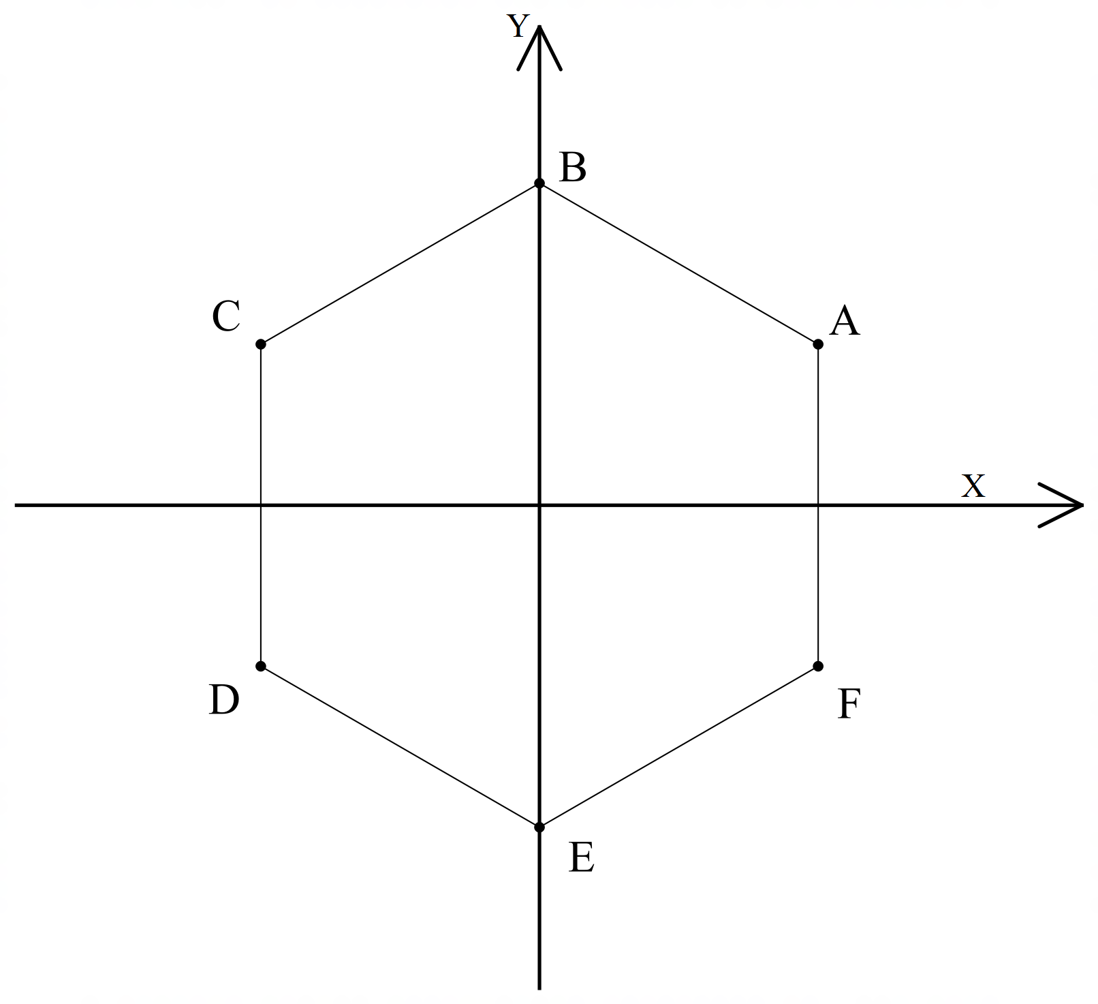

(a) State the rotation that maps A onto E and define its transformation matrix in exact value form.

(b) Show using a transformation matrix that C is also a reflection of A in the y-axis

(c) Considering the points A, B, C, D, E, and F show that the hexagon is symmetrical about the line 